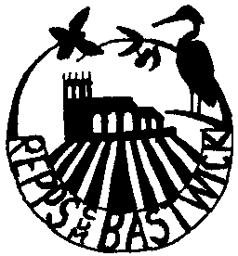
REPPS with BASTWICK PARISH COUNCIL

e-mail c
Local Government Act 1972

NOTICE OF ANNUAL PARISH MEETING FOR REPPS with BASTWICK

Notice is hereby given that: The Annual PARISH Meeting for Repps WITH Bastwick will be held at THE VILLAGE HALL ON TUESDAY THE 1st MAY 2018 AT 7.30pm.

The business transacted will be as follows:

1. Chairman’s welcome.

2. Apologies for absence.

3. Approval of the minutes of the last meeting.

- Parish Council, Chairman’s report.
Parish accounts for the last financial year.

5. Repps Fuel Allotment Charity annual report.

6. County & Borough Councillor’s and Police reports.

7. Village Hall & Playing Field Committee Chairman’s report & Treasurer’s report.

8. Repps PCC annual report.

9. Open floor question and answer session.

10. Date and time of the next meeting.

All Local Government Electors registered to vote in the Civil Parish of Repps cum Bastwick are invited and welcome to attend

Mr F Sharman Parish Council Chair,
22nd April 2018

