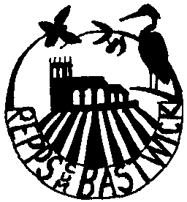 Repps with Bastwick Parish Council

CONSENT FORM

Your privacy is important to us and we would like to communicate with you about the council and its activities. To do so we need your consent. Please fill in your name and address and other contact information below and confirm your consent by ticking the boxes below.

 |  | If you are aged 13 or under your parent or guardian should fill in their details below to confirm their consent
Name | ……………………………………… | ……………………………………………
Address | ……………………………………... | ……………………………………………
 | ……………………………………… | ……………………………………………
 | ……………………………………… | ……………………………………………
Signature | ……………………………………… | ……………………………………………
Date | ……………………………………… | ……………………………………………

Please confirm your consent below. You can grant consent to any or all of the purposes listed. You can find out more about how we use your data from our “Privacy Notice” which is available from our website or from the council Office or at 31 Mill Lane, Acle, NR13 3BJ.

You can withdraw or change your consent at any time by contacting the council office.

We may contact you to keep you informed about what is going on in the council‘s area or other local authority areas including news, events, meetings, clubs, groups and activities. These communications may also sometimes appear on our website, or in printed or electronic form (including social media).
We may contact you about groups and activities you may be interested in participating in.
We may use your name and photo in our newsletters, bulletins or on our website, or our social media accounts (for example a Facebook page or Twitter account).

Keeping in touch:
Yes please, I would like to receive communications by email
Yes please, I would like to receive communications by telephone
Yes please, I would like to receive communications by mobile phone including text message
Yes please, I would like to receive communications by social media (for example Facebook, Twitter, Instagram, WhatsApp)
Yes please, I would like to receive communications by post

