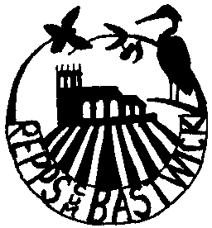
REPPS with BASTWICK PARISH COUNCIL

e-mail c
Local Government Act 1972

NOTICE OF ANNUAL PARISH MEETING FOR REPPS with BASTWICK

Notice is hereby given that: The Annual PARISH Meeting for Repps WITH Bastwick will be held at THE VILLAGE HALL ON TUESDAY THE 3rd MAY 2022 AT 7.30pm

Agenda

The business transacted will be as follows:

- Chairman’s welcome.

- Apologies for absence.

- Approval of the minutes of the last meeting, 6th April 2021.

- Parish Council, Chairman’s report.

- Parish accounts for the last financial year.

- Repps Fuel Allotment Charity annual report.

- County & Borough Councillor’s and Police reports.

- Village Hall & Playing Field Committee Chairman’s report & Treasurer’s report.

- Repps PCC annual report.

- To receive any other annual reports.

- Open floor question and answer session.

- Date and time of the next meeting.

All Local Government Electors registered to vote in the Civil Parish of Repps cum Bastwick are invited and welcome to attend

Mr F Sharman Parish Council Chair,
21st April 2022

