Councillors are summoned to, and members of the public and press are invited to attend the Parish Council Meeting held on 4th June at 8pm at Repps with Bastwick Village Hall. At item 6.3 the public will be invited to give their views and questions to the Parish Council on issues on the agenda or raise issues for the consideration of inclusion at future meetings. This item will generally be limited to a 30 minute duration and will first include County/District Councillors and Police reports.
Tracy Neave, Parish Clerk 30th May 2024

Apologies for Absence

Declaration of interest for items on the agenda and applications for dispensation

Approval of Minutes of the meeting held on 7th May 2024

Matters arising (for information only)
General Election 4th July 2024

Correspondence

NALC updates
  - NPTS training updates
  - Email Repps with Bastwick 24 hour mooring Broads Authority

Public Participation
6.1 Borough and County Councillor Reports, and Police Report
6.2 Flegg Community Land Trust Trustees
6.3 Any other Public Participation

Parish Clerk’s Report – an update on highways and other issues

Allotments – to report any updates and issues

Financial and administration matters, including
  - Bank statements and bank reconciliation
  - Income and Expenditure
  - Payment Schedule/Payments and approval
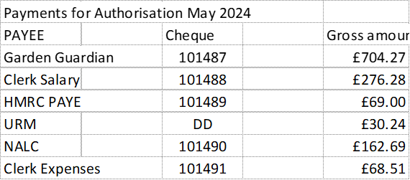

Planning – to consider planning matters
  - New applications: none
  - Appeals: BA/2022/0006 The Old Bridge Road Hotel Site Dismissed Appeal
  - Decisions: none

Matters for reporting or future agendas
- Clerk on annual leave July meeting

Co-option of Parish Councillor
Persuant to Section 1(2) of the Public Bodies (Admission to Meetings Act) 1960 due to the confidential matter of the nature of the business to be transacted, the public and press leave the meeting for consideration of Item 13.

Date and time of the next meeting – the next meeting is scheduled to be held on Tuesday 2nd July 2024 at 8pm at the Village Hall

