Minutes of the Meeting of Repps with Bastwick Parish Council held on

Tuesday 4th 2024 at 8pm at Repps Village Hall

Present: Fred Sharman(Chairperson), Hazel Goodrum, Andrew Wright, John Quickenden, Sam Mitchell, Parish Clerk Tracy Neave, two Members of the Public Representing Flegg Community Land Trust

Apologies for absence: Cllr Tom Ellis

2. Declaration of Interest for items on the agenda: none received

3. Minutes of the last meeting
The minutes of the meeting held on Tuesday 7th May 2024 were agreed and signed by the Chairman.

4. Matters Arising
Notice of General Election 4th July displayed on website

5. Correspondence
5.1 NALC updates
5.2. NPTS training updates
5.3 Email regarding Repps with Bastwick 24 hour mooring Broads Authority

6. Public Participation:
6.1 Borough and County Councillors, Police: nothing to report
6.2 Flegg Community Land Trust: survey to distributed to councillors for review
6.3 Any other public participation: none

7. Parish Clerks Report:
Clerk has contacted Highways regarding street lamps and potholes. Process for GOV.UK
commenced.

8. Allotments: nothing to report

9. Finance
14.1 Bank reconciliation agreed and signed see end of minutes Bank statements signed and
agreed
14.2 Income and expenditure report see end of minutes
14.3 Payment Schedule/payments signed and approved
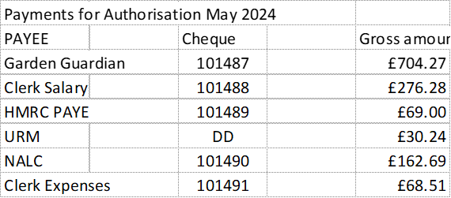

10. Planning Matters:
10.1 New applications: none
10.2 Appeals: BA/2022/0006 The Old Bridge Hotel Site: Dismissed Appeal
10.3 Decisions: none

11. Matters for reporting on future agendas
a. Clerk on annual leave July meeting Cllr Goodrum to take minutes
b. Defibrillator: Clerk to contact Alison Mctaggart regarding defibrillator information as
concerned re lack of information
c. NPTS offering Neighbourhood Plan training in July

12. Co-option of Parish Councillor: Darren Saunders to be co-opted as Parish Councillor

13. Date and time of the next meeting – the next meeting is scheduled to be held on Tuesday 2nd
July 2024 at 8pm at the Village Hall

Meeting closed at 9.05pm

