

REPPS with BASTWICK PARISH COUNCIL

Minutes of the Meeting of Repps with Bastwick Parish Council held on
Tuesday 2nd September 2025 at 8pm at Repps Village Hall

Attendance: Cllrs Mitchell (Chair), Sharman, Ellis, Wright, Saunders, Quickenden, Parish Clerk Tracy Neave, one Member of the Public

- Apologies for absence: Cllr Rudrum
- No declarations of interest in items on the agenda and requests for dispensations

- Approval of Minutes of the meeting held on 2nd September 2025 agreed and signed by Chair Cllr Mitchell

- Matters arising (for information only)
- Rebound Wall: no progress at the moment, so clerk to investigate possibility of grant funding
- Orchard trees: Clerk to investigate plan of trees, and to be rediscussed at next meeting in regard of investigating a tree preservation order to be set on trees

- Borough and County Councillor, Police reports, and public participation
- Borough and County Councillor Reports: nothing to report
- Police report: nothing to report
- Public participation: no discussion points

- Correspondence received
- Recycling survey distributed
- Local Government Reorganisation update

- Parish Clerk’s report - an update on highways and other issues
- Reflective posts installed on Church Road and B1152
- VAT refund received and another to be submitted before year end
- Recycling claim submitted
- Cllr Gudrum booked on Chairperson training at end of September
- Clerk to attend Clerk Seminar in October
- The windows have been chipped in the village hall, no action at present and continue to monitor
- Cllr Wright is no longer a bank signatory. Cllr Goodrum now signatory and awaiting Cllr Saunders to be confirmed as signatory

- Financial and administration matters, including:
- Bank statement and bank reconciliation agreed and signed by Chair
- Payments for approval and late payments after published agenda:
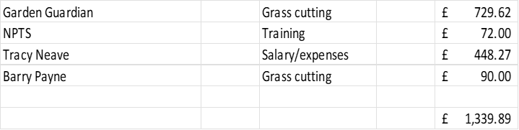

- Annual pay award noted for Clerk as per NALC annual update and clerk’s contract

- Planning Matters:
  - Applications : BA/2025/0234/HOUSEH Replacement of 30 linear metres of timber quay heading 43 Repps Bank Potter Heigham – no objections
  - Decisions None
  - Appeals None

- Review of traffic data collection for August 2025: 213900 vehicles per month use the road on each direction. Average speed of vehicle is 42mph however 58 percent of vehicles speed over this. The Council have now collected a year of data, and with the volume of speed and traffic it seems impossible at times to cross the road.

- Matters for reporting or future agenda
- Cllr Mitchell thanked all those involved in the church and village hall fete/events over the summer
- A parishioner felt the bins require emptying more frequently. Clerk to contact Waste Management
- Trees overhanging road at the caravan campsite, clerk to contact landowner
- Overhanging trees by telephone box require cutting, clerk to contact contractor

- Date and time of the next meeting 7th October 2025 at the Village Hall at 8pm

Meeting closed: 8.45pm

