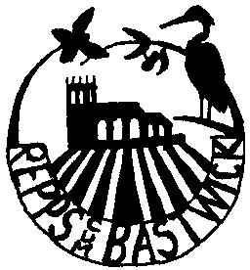

REPPS with BASTWICK PARISH COUNCIL

Councillors are summoned to, and members of the public and press are invited to attend the Parish Council Meeting held on Tuesday 4th November 2025 at 8pm at Repps with Bastwick Village Hall. At item 5c the public will be invited to give their views and questions to the Parish Council on issues on the agenda or raise issues for the consideration of inclusion at future meetings. This item will generally be limited to a 30 minutes duration and will first include County/District Councillors and Police reports.
Tracy Neave, Parish Clerk 30.10.25

AGENDA
- Apologies for absence
- Declarations of interest in items on the agenda and requests for dispensations
- Approval of Minutes of the meeting held on 4th October 2025.
- Matters arising (for discussion)
- Feedback from advert in Chatterbox regarding planters
- Rebound wall update

- Borough and County Councillor, Police reports, and public participation
- Borough and County Councillor Reports
- Police report
- Public participation

- Correspondence received
- None received

- Parish Clerk’s report - an update on highways and other issues including feedback
From Norfolk Parish Training and Support Webinar

- Financial and administration matters, including:
- Bank statement and bank reconciliation
- Payments for approval (any late payments to be agreed)
- Budget preparation
- Grant for funding for Poors Trust Charity
- To confirm dates for next year’s meetings

- Planning Matters:
  - Applications : None
  - Decisions : None
  - Appeals: None

- Review of traffic data collection for October 2025
- Matters for reporting or future agenda
- Date and time of the next meeting 2nd December 2025 at the Village Hall at 8pm

